**Indira Gandhi Delhi Technical University for Women**

**(Established by Govt. of Delhi vide Act 09 of 2012)**

**(Formerly Indira Gandhi Institute of Technology)**

**Kashmere Gate, Delhi - 110006**



**LABORATORY FILE**

**for**

**Web Technologies**

**MCA 207**

**Submitted by:**

**Submitted to:**

Ms. Ankita Singh Roopal Mittal

MCA, 3rd Sem

02004092019

**Date: 15-10-2020**

**LAB 10 WORK**

**Ques 1:** **Write a simple PHP script which will check the following on user input data:**

* **Enter your university name:**
* **length of the input is greater than 10 then show an error**
* **Input is equals to igdtuw then display ok otherwise show an error**
* **Display reverse of the data**

**PHP Code: (igdtuw.php)**

<html>

<head>

<title> Operations using PHP </title>

</head>

<body>

<form action="ques1.php" method="post">

Enter your University name <input type="text" name="string_value" required/>

<input type="submit" value="check"/>

</form>

</body>

</html>

**PHP Code: (validations)(ques1.php)**

<html>

<body>

<?php

$string= $_POST['string_value'];

$string_check="igdtuw";

if(strlen($string) >=10)

echo("ERROR! Length should be less than 10 ; ");

if($string == $string_check)

echo "OK";

else

echo("ERROR! Not the correct university name ; ");

echo("; Reverse of the string is: ");

echo strrev($string);

?>

</body>

</html>

**Output:**

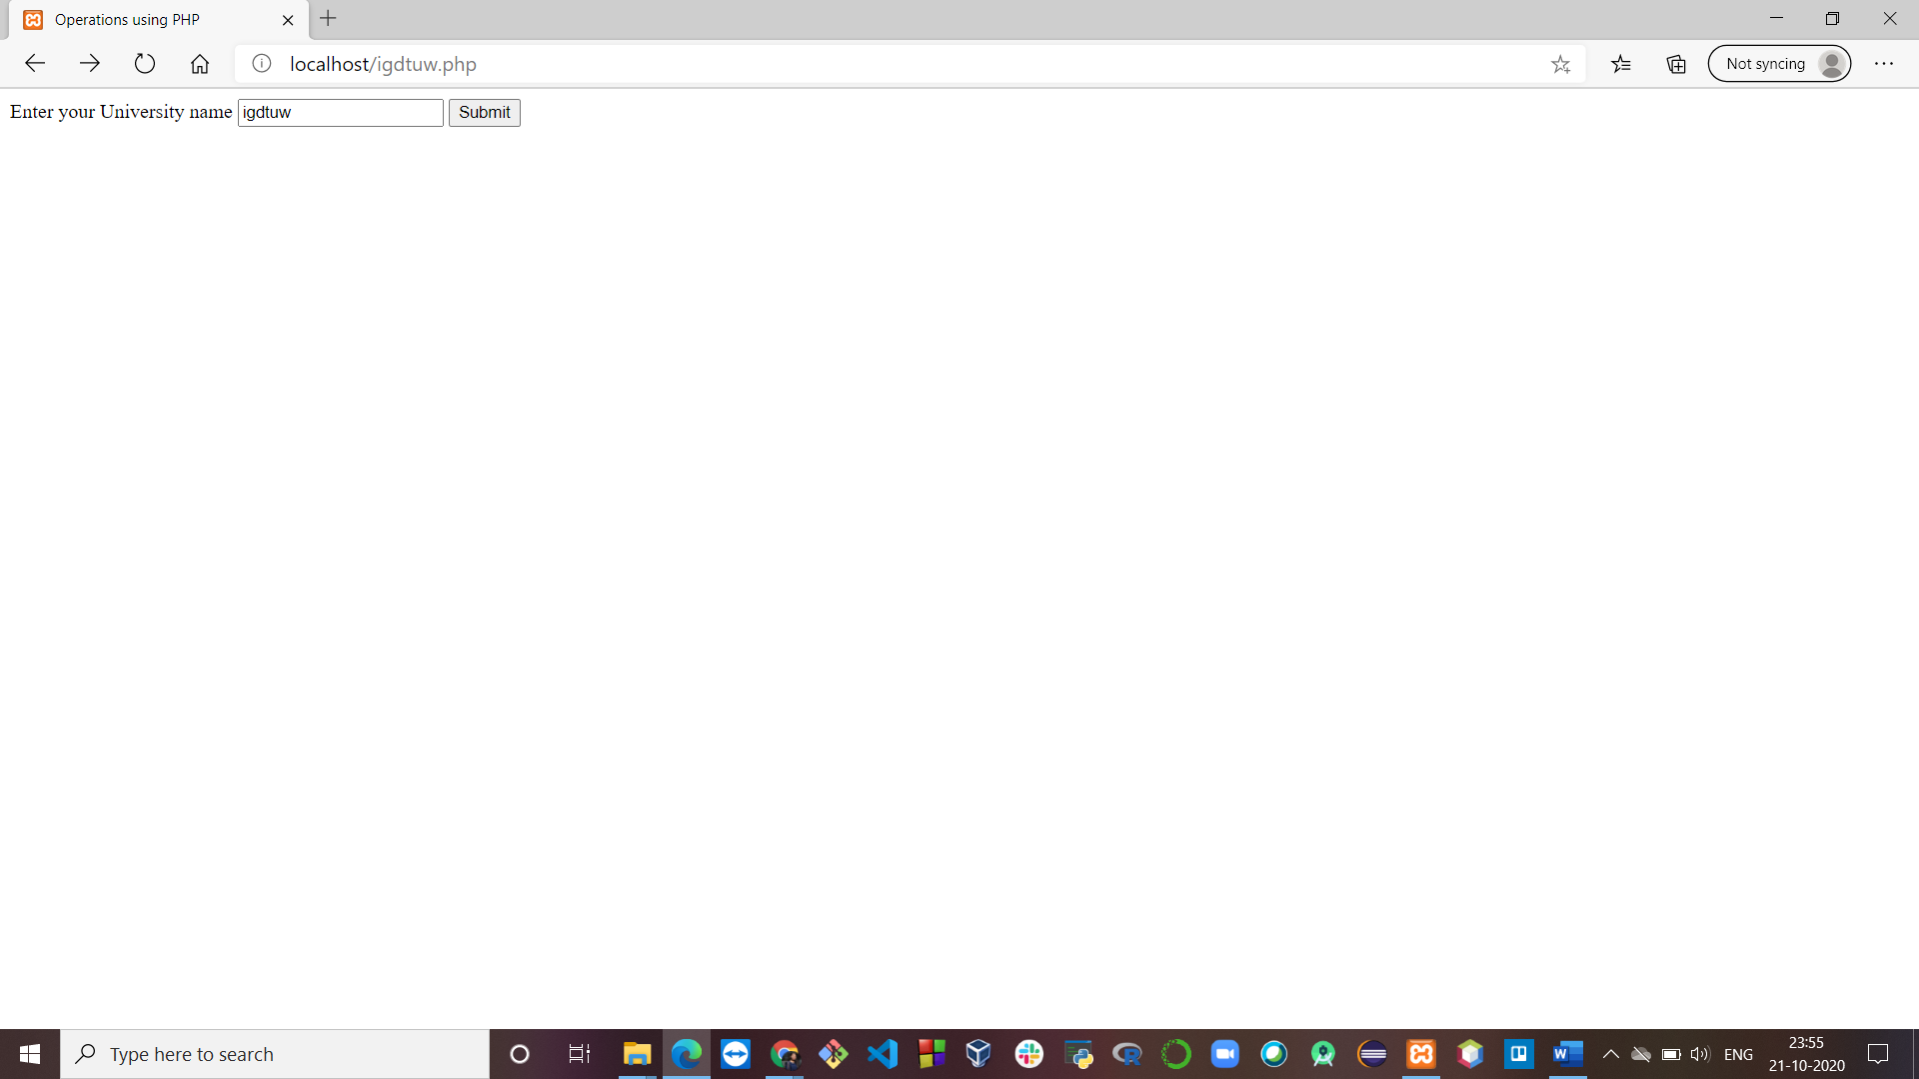

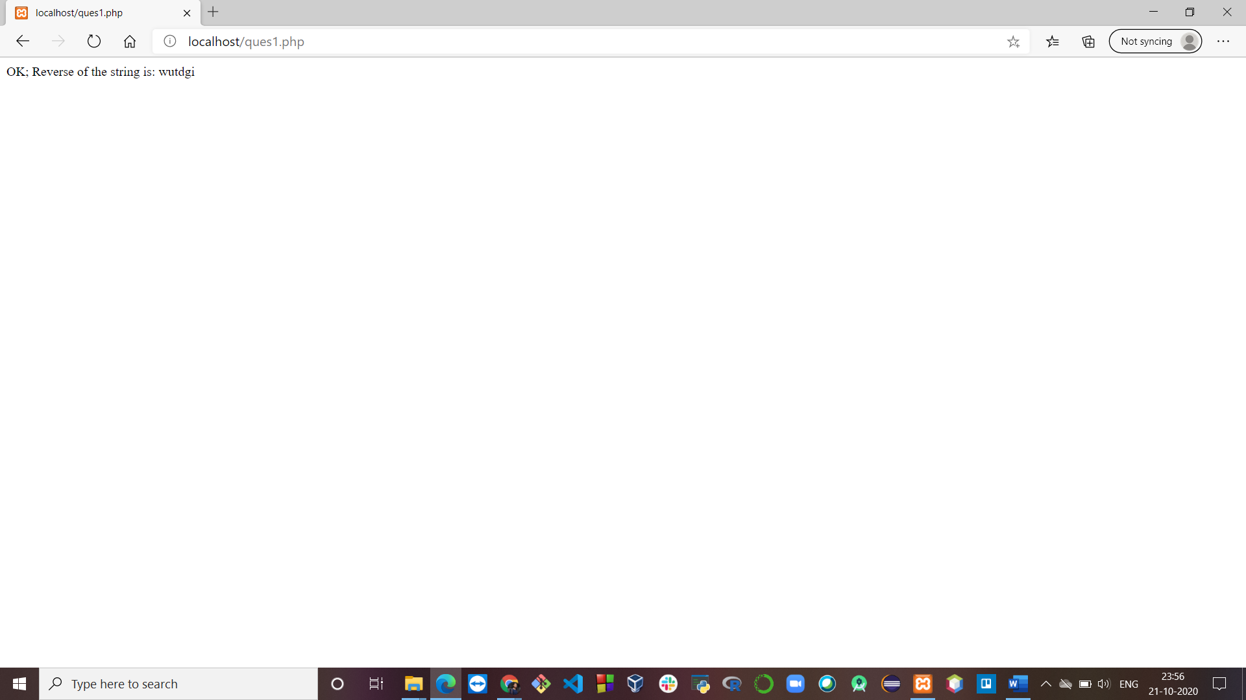

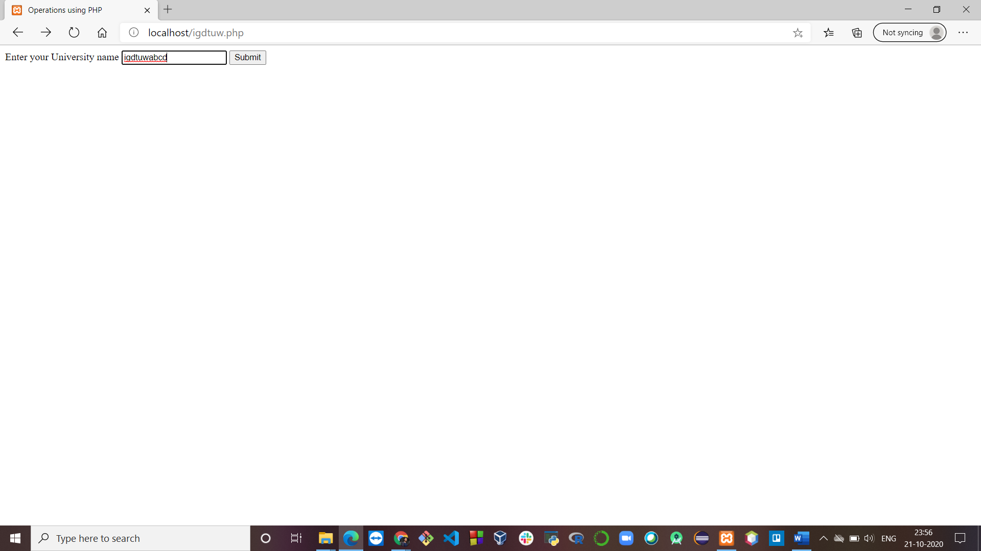

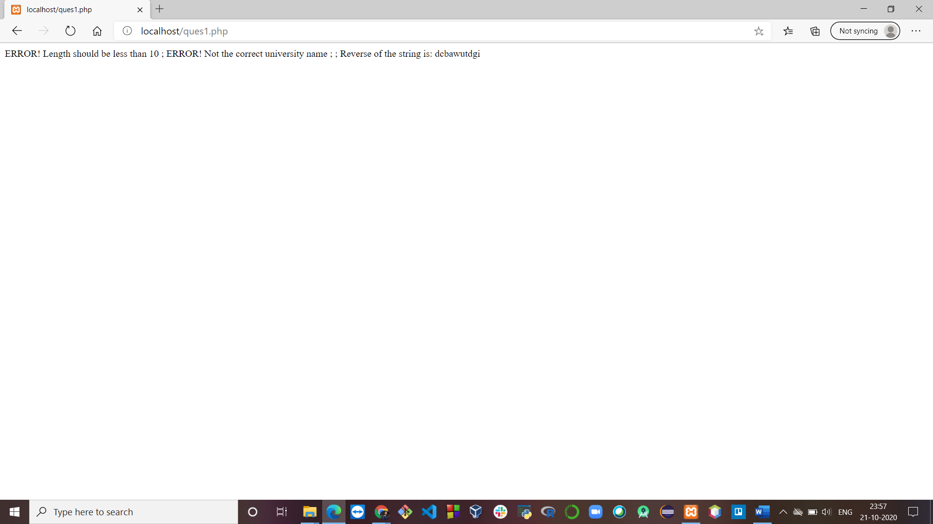

**Ques 2: Write a PHP script to display the details of student’s registration form using get and post.**

**HTML Code: (GET method)**

<html>

<head>

<title>

Register

</title>

<script src="validation_register.js"></script>

<link rel="stylesheet" href="validation_register.css">

</head>

<body onload='document.register.fname.focus()'>

<div>

<h2>Registration Form</h2>

<h5>Want to proceed further? Register yourself!</h5>

<form name="register" onsubmit="return validateForm()" method="get" action="welcome_get.php">

<label for="fname">First Name: </label>

<input type="text" id="fname" name="fname" required><br><br>

<label for="lname">Last Name: </label>

<input type="text" id="lname" name="lname" required><br><br>

<label for="fname">Email Id: </label>&nbsp;&nbsp;

<input type="text" id="email" name="email" required><br><br>

Gender: &nbsp;

<input type="radio" id="gender" name="gender" value="gender">

<label for="male">Male</label>

<input type="radio" id="female" name="gender" value="female">

<label for="female">Female</label>

<input type="radio" id="other" name="gender" value="other">

<label for="other">Prefer not to say</label> <br> <br>

<label for="cars">Birthday:</label>&nbsp;&nbsp;

<select id="day" name="day">

<option value="1">1</option>

<option value="2">2</option>

<option value="3">3</option>

<option value="4">4</option>

<option value="5">5</option>

<option value="6">6</option>

<option value="7">7</option>

<option value="8">8</option>

<option value="9">9</option>

<option value="10">10</option>

<option value="11">11</option>

<option value="12">12</option>

<option value="13">13</option>

<option value="14">14</option>

<option value="15">15</option>

<option value="16">16</option>

<option value="17">17</option>

<option value="18">18</option>

<option value="19">19</option>

<option value="20">20</option>

<option value="21">21</option>

<option value="22">22</option>

<option value="23">23</option>

<option value="24">24</option>

<option value="25">25</option>

<option value="26">26</option>

<option value="27">27</option>

<option value="28">28</option>

<option value="29">29</option>

<option value="30">30</option>

<option value="31">31</option>

</select>

<select id="month" name="month">

<option value="Jan">January</option>

<option value="Feb">February</option>

<option value="Mar">March</option>

<option value="Apr">April</option>

<option value="May">May</option>

<option value="June">June</option>

<option value="July">July</option>

<option value="Aug">August</option>

<option value="Sept">September</option>

<option value="Oct">October</option>

<option value="Nov">November</option>

<option value="Dec">December</option>

</select> <br> <br>

Employment type:

<input type="checkbox" id="1" name="emp1" value="Student">

<label for="student"> Student</label>

<input type="checkbox" id="2" name="emp2" value="Job">

<label for="job"> Looking for a job</label>

<input type="checkbox" id="3" name="emp3" value="Intern">

<label for="intern"> Looking for internship</label> <br> <br>

<label for="textt">Tell us something about yourself:</label> <br>

<textarea id="textt" name="textt" rows="4" cols="50"></textarea><br><br>

<label for="lname">Password: </label>&nbsp; &nbsp;&nbsp; &nbsp;&nbsp; &nbsp;&nbsp; &nbsp;&nbsp;

<input type="password" id="password" name="password" onkeyup='check();' ><br><br>

<label for="lname">Confirm Password: </label>

<input type="password" id="cpassword" name="cpassword" onkeyup='check();' ><br><br>

<button type="submit" onclick="validateForm()">Register</button>

<button type="reset"> Reset </button>

</form>

</div>

</body>

</html>

**PHP Code:**

<html>

<body>

Welcome <?php echo $_GET["fname"]; ?>

<?php echo $_GET["lname"]; ?><br>

Your email address is: <?php echo $_GET["email"]; ?><br>

Your birth date is: <?php echo $_GET["day"]; ?>-

<?php echo $_GET["month"]; ?><br>

</body>

</html>

**Output:**

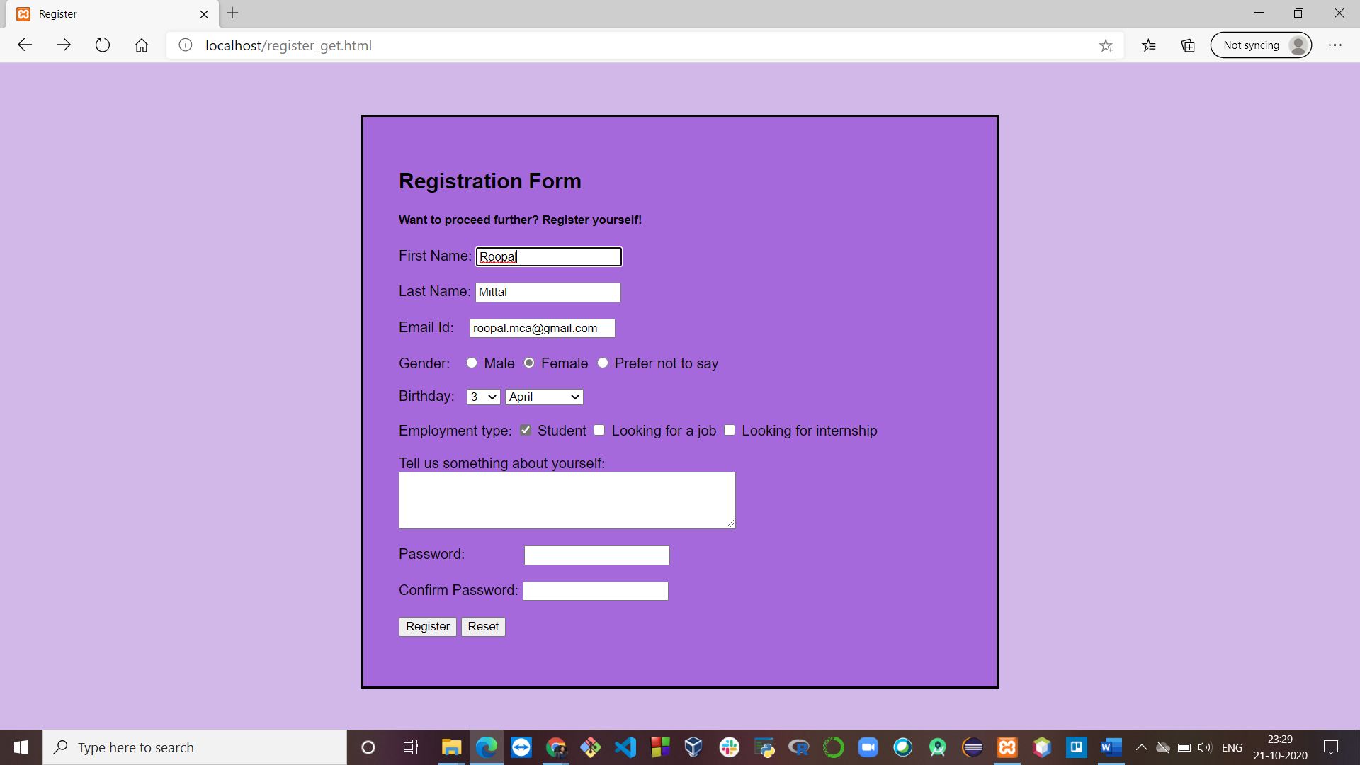

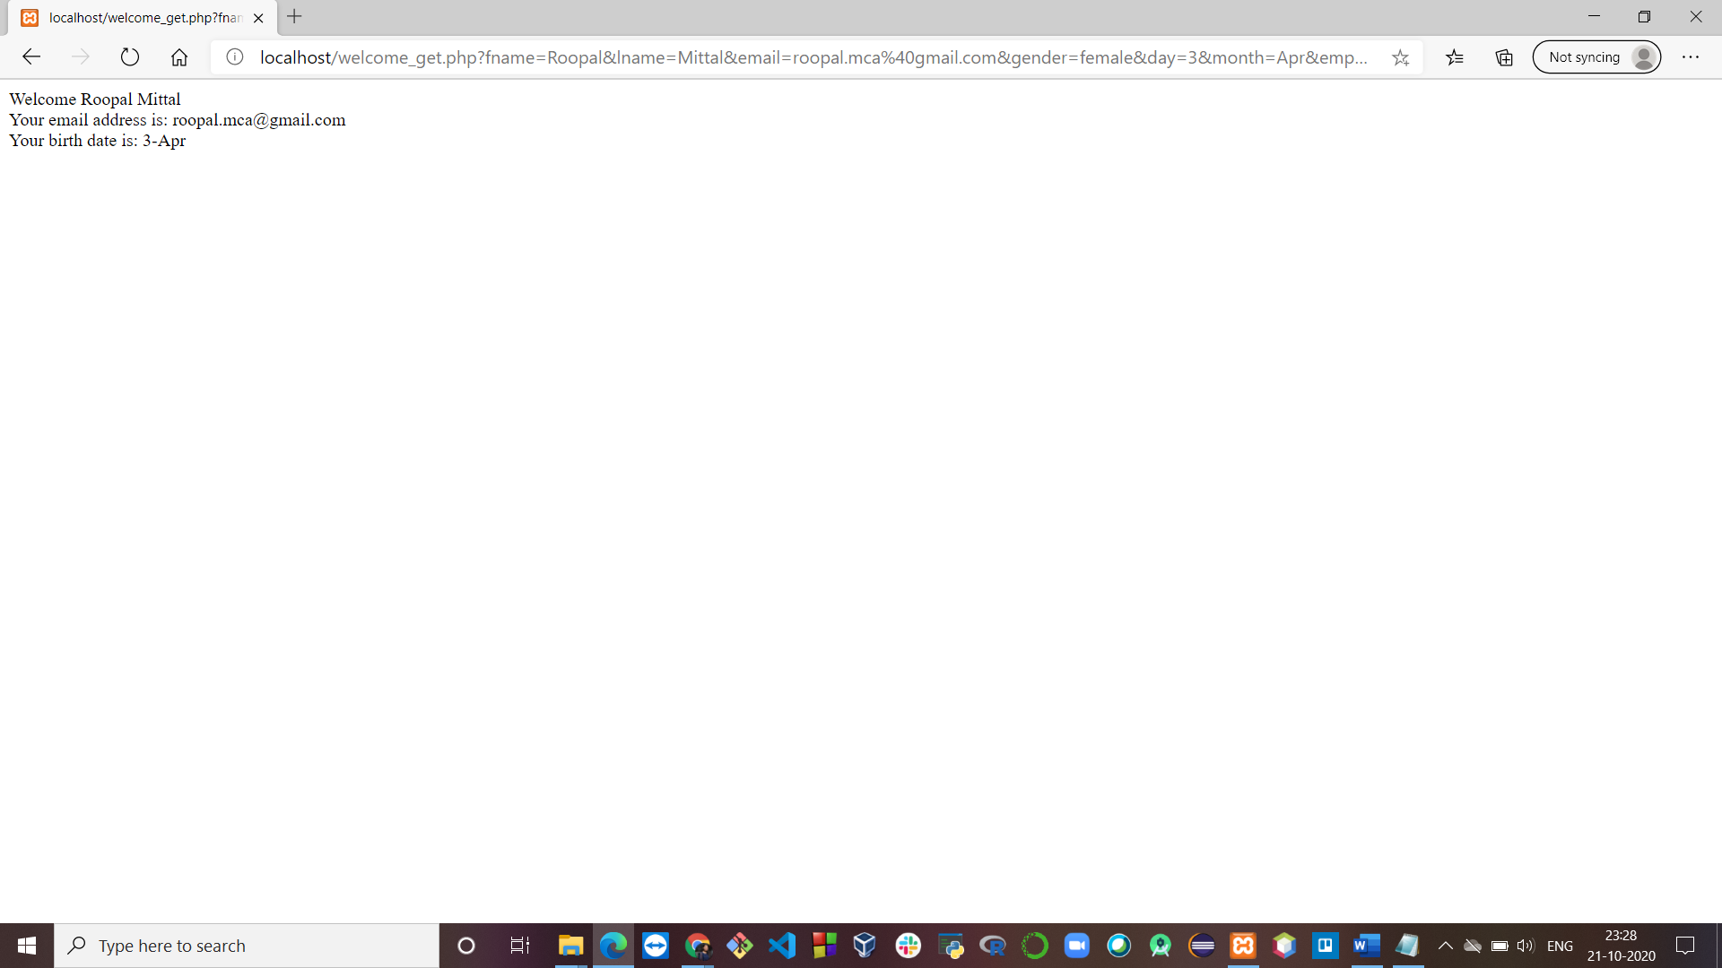

**HTML Code: (POST method)**

<html>

<head>

<title>

Register

</title>

<script src="validation_register.js"></script>

<link rel="stylesheet" href="validation_register.css">

</head>

<body onload='document.register.fname.focus()'>

<div>

<h2>Registration Form</h2>

<h5>Want to proceed further? Register yourself!</h5>

<form name="register" onsubmit="return validateForm()" action="welcome_post.php" method="post">

<label for="fname">First Name: </label>

<input type="text" id="fname" name="fname" required><br><br>

<label for="lname">Last Name: </label>

<input type="text" id="lname" name="lname" required><br><br>

<label for="fname">Email Id: </label>&nbsp;&nbsp;

<input type="text" id="email" name="email" required><br><br>

Gender: &nbsp;

<input type="radio" id="gender" name="gender" value="gender">

<label for="male">Male</label>

<input type="radio" id="female" name="gender" value="female">

<label for="female">Female</label>

<input type="radio" id="other" name="gender" value="other">

<label for="other">Prefer not to say</label> <br> <br>

<label for="cars">Birthday:</label>&nbsp;&nbsp;

<select id="day" name="day">

<option value="1">1</option>

<option value="2">2</option>

<option value="3">3</option>

<option value="4">4</option>

<option value="5">5</option>

<option value="6">6</option>

<option value="7">7</option>

<option value="8">8</option>

<option value="9">9</option>

<option value="10">10</option>

<option value="11">11</option>

<option value="12">12</option>

<option value="13">13</option>

<option value="14">14</option>

<option value="15">15</option>

<option value="16">16</option>

<option value="17">17</option>

<option value="18">18</option>

<option value="19">19</option>

<option value="20">20</option>

<option value="21">21</option>

<option value="22">22</option>

<option value="23">23</option>

<option value="24">24</option>

<option value="25">25</option>

<option value="26">26</option>

<option value="27">27</option>

<option value="28">28</option>

<option value="29">29</option>

<option value="30">30</option>

<option value="31">31</option>

</select>

<select id="month" name="month">

<option value="Jan">January</option>

<option value="Feb">February</option>

<option value="Mar">March</option>

<option value="Apr">April</option>

<option value="May">May</option>

<option value="June">June</option>

<option value="July">July</option>

<option value="Aug">August</option>

<option value="Sept">September</option>

<option value="Oct">October</option>

<option value="Nov">November</option>

<option value="Dec">December</option>

</select> <br> <br>

Employment type:

<input type="checkbox" id="1" name="emp1" value="Student">

<label for="student"> Student</label>

<input type="checkbox" id="2" name="emp2" value="Job">

<label for="job"> Looking for a job</label>

<input type="checkbox" id="3" name="emp3" value="Intern">

<label for="intern"> Looking for internship</label> <br> <br>

<label for="textt">Tell us something about yourself:</label> <br>

<textarea id="textt" name="textt" rows="4" cols="50"></textarea><br><br>

<label for="lname">Password: </label>&nbsp; &nbsp;&nbsp; &nbsp;&nbsp; &nbsp;&nbsp; &nbsp;&nbsp;

<input type="password" id="password" name="password" onkeyup='check();' ><br><br>

<label for="lname">Confirm Password: </label>

<input type="password" id="cpassword" name="cpassword" onkeyup='check();' ><br><br>

<button type="submit" onclick="validateForm()">Register</button>

<button type="reset"> Reset </button>

</form>

</div>

</body>

</html>

**PHP Code:**

<html>

<body>

WELCOME <?php echo $_POST["fname"];?>

<?php echo $_POST["lname"]; ?><br>

Your Email address is: <?php echo $_POST["email"];?><br>

Your birth date is: <?php echo $_POST["day"]; ?>-

<?php echo $_POST["month"]; ?>

</body>

</html>

**Output:**



**Ques 3: Write a php script to display the result (+,-,*,/) calculator (a, b are two inputs).**

**PHP Code:**

<!DOCTYPE html>

<html>

<head>

<title></title>

</head>

<body>

<?php

$second="";

$first="";

if(isset($_POST['submit']))

{

$first = $_POST['firstNumber'];

$second = $_POST['secondNumber'];

switch ($_POST['submit'])

{

case 'Addition':

$result=$_POST['firstNumber']+$_POST['secondNumber'];

break;

case 'Subtration':

$result=$_POST['firstNumber']-

$_POST['secondNumber'];

break;

case 'Multiplication':

$result=$_POST['firstNumber']*$_POST['secondNumber'];

break;

case 'Division':

$result=$_POST['firstNumber']/$_POST['secondNumber'];

break;

default:

$result="";

break;

}

}

?>

<form action="#" method="POST">

<input type="number" name="firstNumber"

required="required" value="<?php echo $first;?>">

<input type="number" name="secondNumber"

required="required" value="<?php echo $second;?>">

<input type="submit" name="submit" value="Addition">

<input type="submit" name="submit" value="Subtration">

<input type="submit" name="submit"

value="Multiplication">

<input type="submit" name="submit" value="Division">

</form>

<?php

if(isset($_POST['submit'])){

echo "<h3>Answer : $result</h3>";

}

?>

</body>

</html>

**Output:**

**Addition**

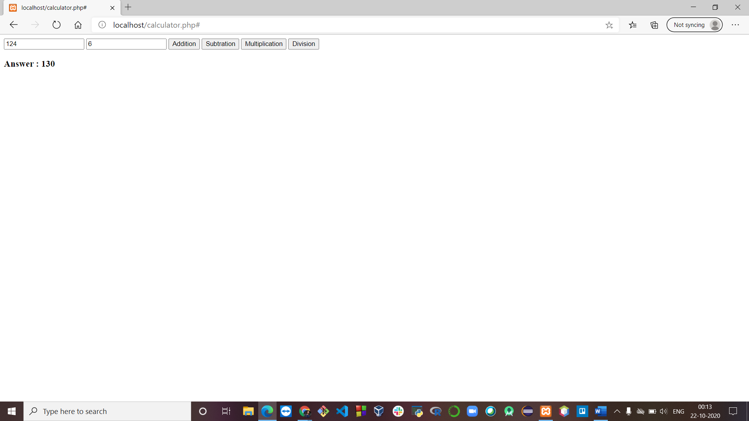

**Subtraction**

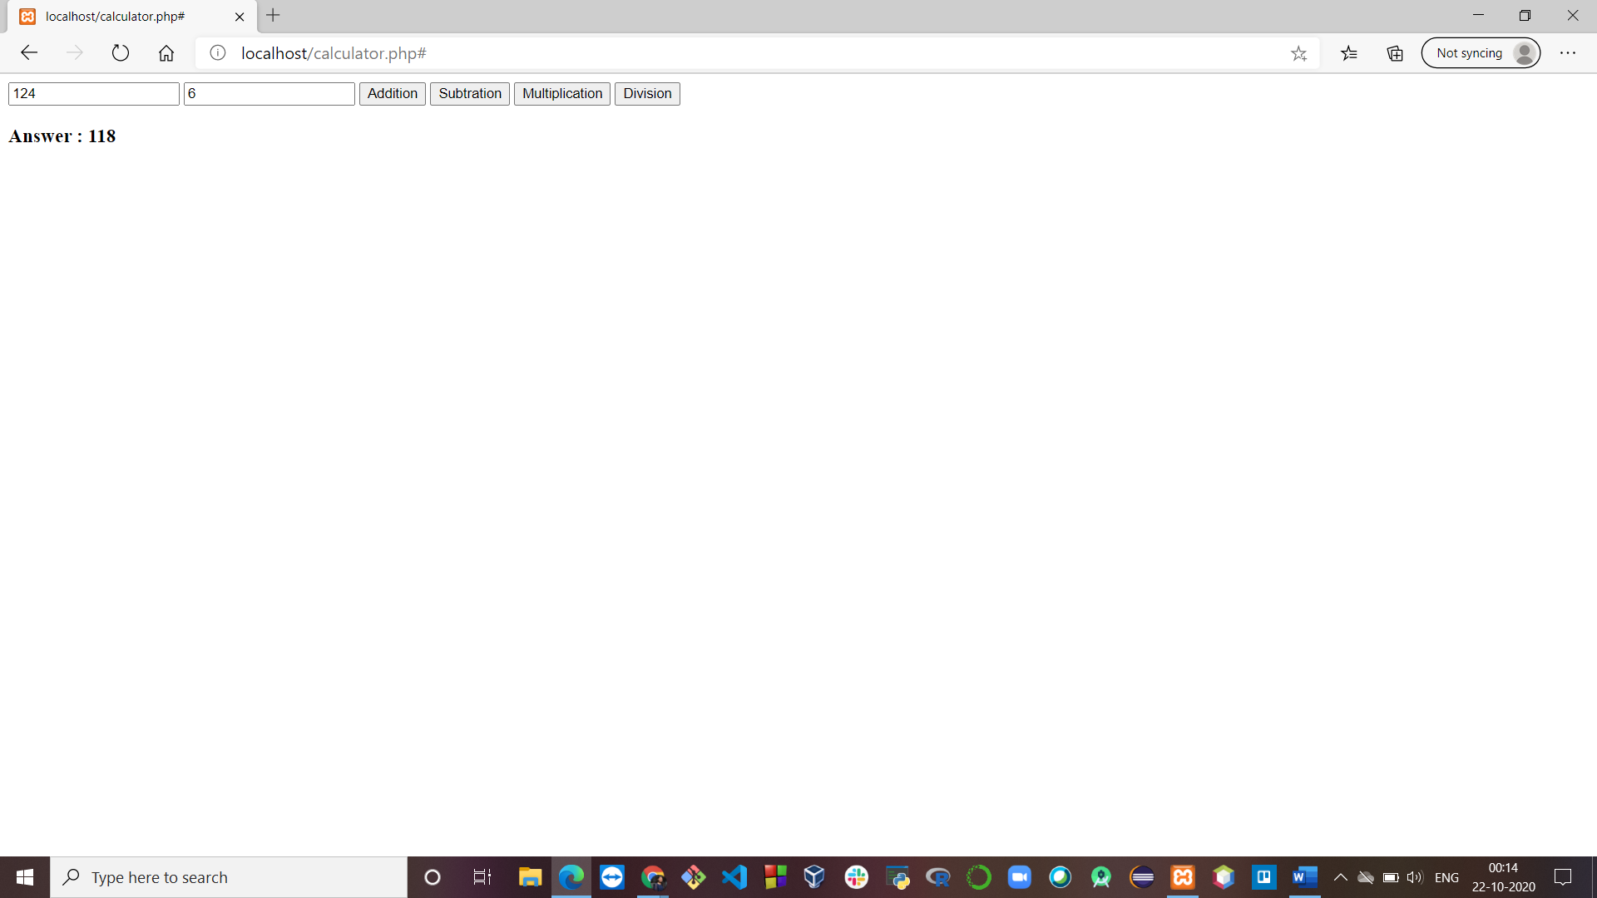

**Multiplication**

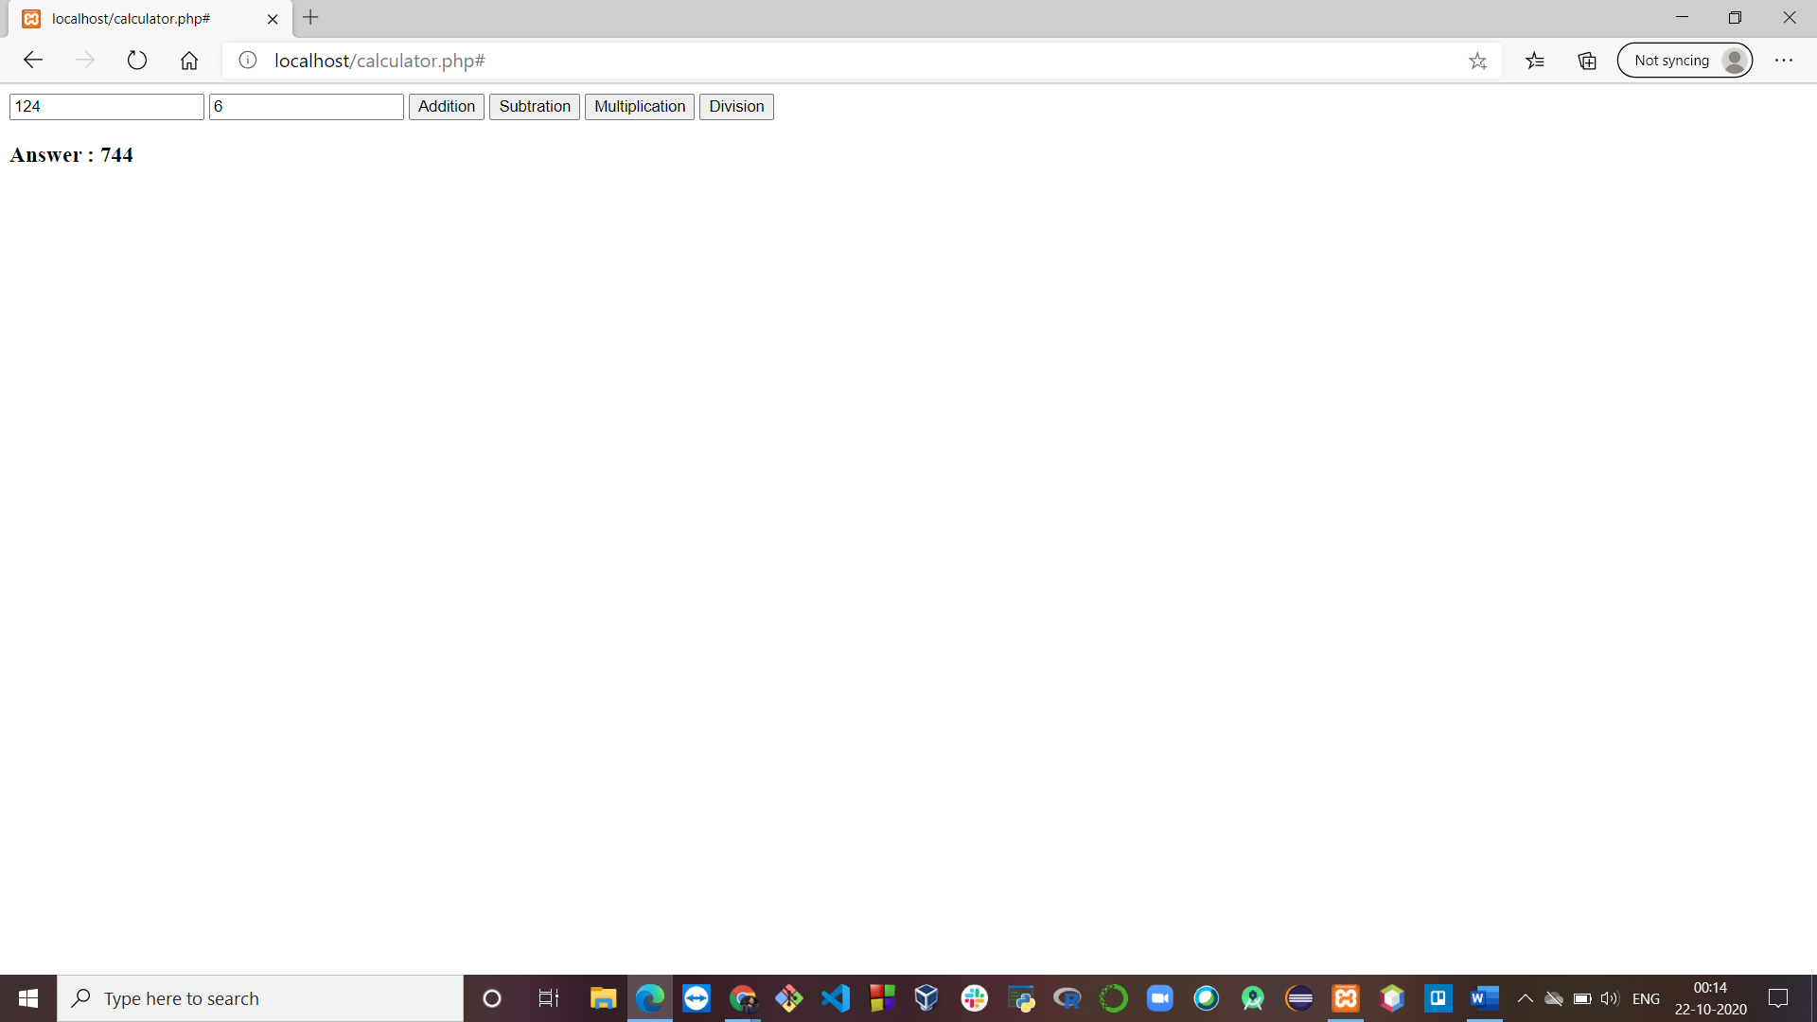

**Division**

